**SubQueries:** A subquery is a form of an SQL statement that appears inside another SQL statement.

**Joins:** Sometimes it is necessary to work with multiple tables as though they were single entity. Then a single SQL sentence can manipulate data from all the tables. Joins are used to achieve this.

**Types of joins:**

1. **Inner Join:** This join compares two columns from two tables with the equivalence operator ‘=’. The Inner Join returns all rows from both tables where there is a match.
2. **Outer Join:** This type of join can be used in situations where it is desired to select all rows from the table on the left or right or both regardless of whether the other table has values in common and enter NULL where data is missing.
3. **Cross Join:** A cross join returns what’s known as a Cartesian product.

**Required table for this lab:**

**Table:** **Client_Master**

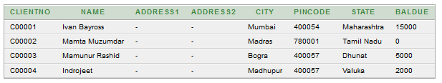

**Table:** **Product_Master**

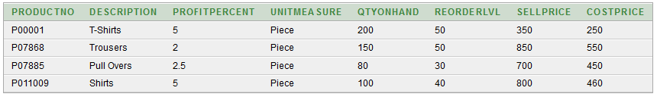

**Table:** **SalesMan_Master**

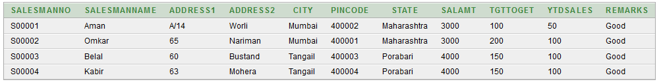

**Table:** **Sales_Order**

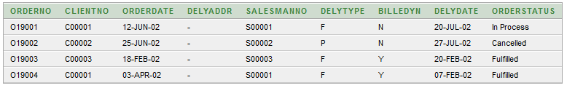

**Table:** **Sales_Order_Details**

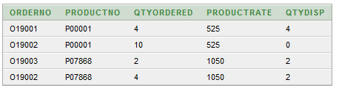

**Exercise on Joins and correlation:**

1. Find out the products which have been sold to ‘Ivan Bayross’.

**SQL:**

SELECT Sales_Order_Details.ProductNo, Product_Master.Description FROM Sales_Order_Details, Sales_Order, Product_Master, Client_Master WHERE Sales_Order_Details.ProductNo = Product_Master.ProductNo AND Sales_Order.OrderNo = Sales_Order_Details.OrderNo AND Client_Master.ClientNo = Sales_Order.ClientNo AND Client_Master.Name = 'Ivan Bayross';

**Result:**

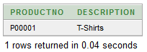

1. Find out the products and their quantities that will have to be delivered in the current month (20-FEB-02).

**SQL:**

SELECT SOD.ProductNo, PM.Description FROM Sales_Order_Details SOD, Sales_Order SO, Product_Master PM WHERE PM.ProductNo=SOD.ProductNo AND SO.OrderNo=SOD.OrderNo AND TO_CHAR(DelyDate)=TO_CHAR(TO_DATE('20-FEB-02'));

**Result:**

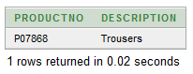

1. List the ProductNo and Description of constantly sold product.

**SQL:**

SELECT DISTINCT Product_Master.ProductNo, Description

FROM Sales_Order_Details, Product_Master

WHERE Product_Master.ProductNo=Sales_Order_Details.ProductNo;

**Result:**

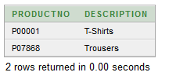

1. Find the name of clients who have purchased ‘Trousers’.

**SQL:**

SELECT DISTINCT Sales_Order.ClientNo, Client_Master.Name

FROM Sales_Order_Details, Sales_Order, Product_Master, Client_Master

WHERE Product_Master.ProductNo=Sales_Order_Details.ProductNo

AND Sales_Order.OrderNo=Sales_Order_Details.OrderNo

AND Client_Master.ClientNo=Sales_Order.ClientNo

AND Description='Trousers';

**Result:**

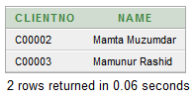

1. Find the products for the orders placed by ‘Ivan Bayross’ and ‘Mamta Muzumdar’.

**SQL:**

SELECT SOD.ProductNo, PM.Description

FROM Sales_Order_Details SOD, Sales_Order SO, Product_Master PM, Client_Master CM

WHERE PM.ProductNo=SOD.ProductNo

AND SO.OrderNo=SOD.OrderNo

AND CM.ClientNo=SO.ClientNo

AND(CM.Name='Ivan Bayross' OR CM.Name='Mamta Muzumdar')

GROUP BY SOD.ProductNo, PM.Description;

**Result:**

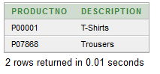

1. Find the products for the orders placed by ClientNo ‘C00001’ and ‘C00002’.

**SQL:**

SELECT SO.ClientNo,SOD.ProductNo, PM.Description

FROM Sales_Order_Details SOD, Sales_Order SO, Product_Master PM, Client_Master CM

WHERE PM.ProductNo=SOD.ProductNo

AND SO.OrderNo=SOD.OrderNo

AND CM.ClientNo=SO.ClientNo

AND(SO.ClientNo='C00001' OR SO.ClientNo='C00002')

GROUP BY So.ClientNo, SOD.ProductNo, PM.Description;

**Result:**

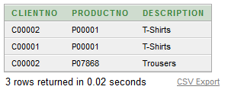

**Exercise on SubQueries:**

1. Find the ProductNo and description of non-moving products i.e. products not being sold.

**SQL:**

SELECT ProductNo, Description FROM Product_Master WHERE ProductNo NOT IN (SELECT ProductNo FROM Sales_Order_Details);

**Result:**

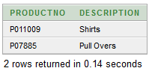

1. List the customer Name, Address1, Address2, City and PinCode for the client who has placed order no ‘O19001’.

**SQL:**

SELECT Name, Address1, Address2, City, State, PinCode FROM Client_Master WHERE ClientNo IN(SELECT ClientNo FROM Sales_Order WHERE OrderNo='O19001');

**Result:**

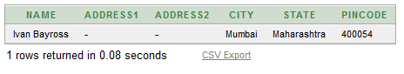

1. List the client names that have placed orders before the month of May’02.

**SQL:**

SELECT ClientNo, Name FROM Client_Master WHERE ClientNo IN(SELECT ClientNo FROM Sales_Order WHERE TO_CHAR(OrderDAte,'MON,YY')<'MAY,02');

**Result:**

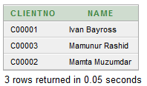

1. List if the Product ‘Trousers’ has been ordered by any client and print the ClientNo, Name to whom it was sold.

**SQL:**

SELECT ClientNo, Name FROM Client_Master WHERE ClientNo IN(SELECT ClientNo FROM Sales_Order WHERE OrderNo IN(SELECT OrderNo FROM Sales_Order_Details WHERE ProductNO IN(SELECT ProductNo FROM Product_Master WHERE Description ='Trousers')));

**Result:**

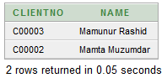

1. List the names of clients who have placed orders worth Rs. 1000 and more.

**SQL:**

SELECT Name FROM Client_Master WHERE ClientNO IN(SELECT ClientNo FROM Sales_Order WHERE OrderNo IN(SELECT OrderNo FROM Sales_Order_Details WHERE (QtyOrdered*ProductRate)>=1000));

**Result:**

